Guidelines for Proper Completion of Marriage License
By state law, it is the responsibility of the individual performing the ceremony to complete and sign the marriage license. In addition, they must keep a record of all marriage ceremonies performed.
Please remember the following when completing the marriage license:
- Marriage licenses are to be filled out in dark ink only. Do not use a light color or pencil on license. Please be sure to print legibly on the license.

The Marriage License is the portion that contains the raised seal and has a signature of a Deputy or the Recorder.

- The couple does NOT sign the marriage license.

- Return by mail or in person to the County Recorder’s Office where you originally applied for your license (Johnson County, 300 North Holden, Suite 305, Warrensburg, MO 64093) within 15 days after your ceremony.
Below is a sample marriage license to use as a guideline. If you have questions please feel free to call the office at 660-747-6811.
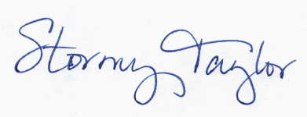
Thank you in advance for your attention in this matter.

Recorder of Deeds
Johnson County
Please note, this should be the county where the ceremony is performed.
